**International Debt Statistics Analysis Report**

The following is the analysis of international debt data collected by The World Bank. The dataset contains information about the amount of debt (in USD) owed by developing countries across several categories.

Below is a description of the table:

| **Column** | **Definition** | **Data Type** |
| --- | --- | --- |
| country_name | Name of the country | varchar |
| country_code | Code representing the country | varchar |
| indicator_name | Description of the debt indicator | varchar |
| indicator_code | Code representing the debt indicator | varchar |
| debt | Value of the debt indicator for the given country (in current US dollars) | float |

**What is the number of distinct countries present in the database?**

SELECT

COUNT(DISTINCT country_name) as no_distinct_countries

FROM international_debt;



**What country has the highest amount of debt?**

SELECT

country_name, SUM(debt) as total_debt

FROM international_debt

GROUP BY country_name

ORDER BY total_debt DESC

LIMIT 1;



**What country has the lowest amount of repayments?**

**(indicated by the "DT.AMT.DLXF.CD" indicator code)**

SELECT

country_name,

indicator_name,

MIN(debt) AS lowest_repayment

FROM international_debt

WHERE indicator_code='DT.AMT.DLXF.CD'

GROUP BY country_name, indicator_name

ORDER BY lowest_repayment

LIMIT 1;



**What are the Top 5 Countries by Total Debt (Principal + Interest)**

SELECT

country_name,

SUM(debt) AS total_debt

FROM

international_debt

WHERE

indicator_code IN ('DT.AMT.DLXF.CD', 'DT.INT.DLXF.CD')

GROUP BY

country_name

ORDER BY

total_debt DESC

LIMIT 5;

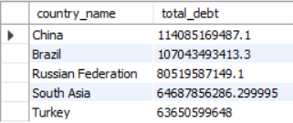

**Average Debt by Debt Type**

SELECT

indicator_name,

ROUND(AVG(debt), 2) AS average_debt

FROM

international_debt

GROUP BY

indicator_name

ORDER BY

average_debt DESC;

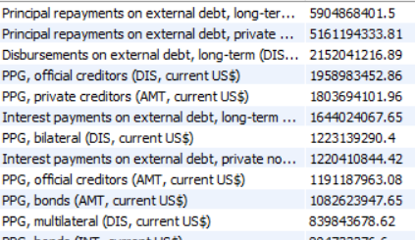

And more

**Author:** Owais Ali

**Github Link:** https://github.com/0waisAli